**Dorothy (Dottie) Joanne List**

**and Don Raasch**

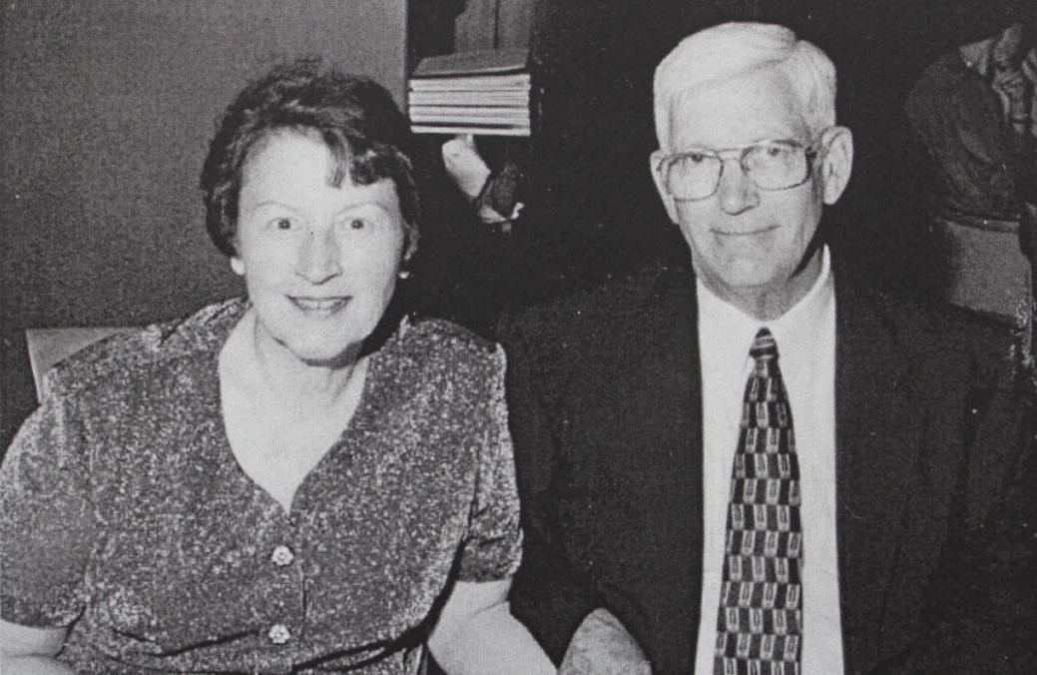

Dorothy Joanne List and husband, Donald Thomas Raasch – about 1990 ??

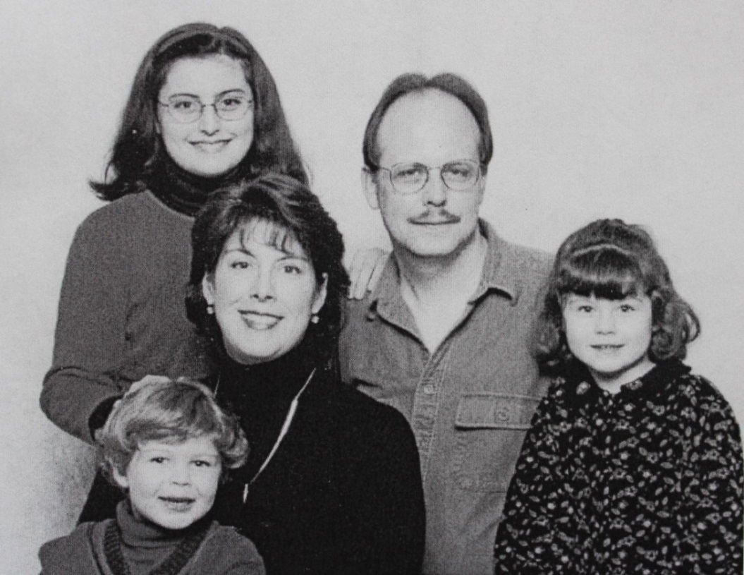

Debra Raasch Brown family (l-r): Garret, Kayla Paterson, Debbie (daughter

of Don & Dottie List Raasch), Barry and Delaney Brown – about 2000